SE: Machine Learning
Department of Computer and Software Engineering

Course Instructor: Dr. Ahmed Raza | Date: 26-February-2026
Day: Thursday | Semester: 6th

Lab 3: Hard Margin SVM — Geometry of Maximum Margin

Lab Title | CLO | BT | PLO | Weightage
Hard Margin SVM:
Geometry of Maximum Margin

Name | Roll Number | Report /15 | Viva /5 | Total /20
Zunaira Abdul Aziz | BSSE23058

Checked on:
Signature:

Learning Outcomes
After completing this lab, the student will be able to:

  - Explain the maximum margin principle.
  - Compute geometric margin width.
  - Verify hard-margin constraints numerically.
  - Identify support vectors and interpret their role.
  - Analyze geometric sensitivity to scaling and point removal.

Equipment Required
  - PC with Python 3.x
  - NumPy
  - Matplotlib
  - scikit-learn

Theory and Background

Hard Margin SVM solves:

1
min w ²

w,b 2
Subject to:

y_{i}(w^{T} x_{i} + b) ≥ 1
Geometric margin width:
2
w
Support vectors satisfy:

y_{i}(w^{T} x_{i} + b) = 1 Only these points determine the separating boundary.

Part A — Training a Hard Margin Classifier
Task A1: Generate Separable Dataset (2 Marks)
Implementation Box
Generate a 2D linearly separable dataset using a fixed random seed. Plot the dataset with labels.
def generate_dataset(n=100, seed=42):
np.random.seed(seed)
X = np.random.randn(n, 2)
X[50:] += 5
y = np.array([-1] * 50 + [1] * 50)
return X, y

Task A2: Train Linear SVM (2 Marks)
Implementation Box
Train a linear SVM using sklearn:
SVC(kernel=’linear’)
This model will compute the maximum-margin separating hyperplane.
def train_linear_svm(X, y):
model = SVC(kernel="linear", C=1e10)
model.fit(X, y)
return model

Task A3: Extract Parameters (2 Marks)
Analysis Box
Extract w and b. Print w .
def extract_parameters(model):
w = model.coef_[0]
b = model.intercept_[0]
return w, b
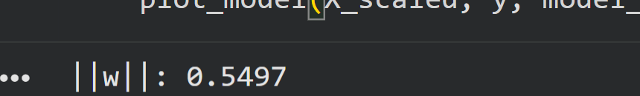

Part B — Verifying Hard Constraints
Task B1: Constraint Verification (3 Marks)
Analysis Box
Compute y_{i}(w^{T} x_{i} + b). Report minimum value. Verify all values ≥ 1.
def compute_margins(X, y, w, b):
return y * (np.dot(X, w) + b)

def verify_constraints(margins):
min_margin = np.min(margins)
print(f"Minimum functional margin: {min_margin:.4f}")
print(
f"All constraints satisfied (margin >= 1): {min_margin >= 0.999}"
)

Task B2: Margin Visualization (2 Marks)
Implementation Box
Compute geometric margin width. Plot margin lines w^{T} x + b = ±1.
def compute_margin_width(w):
return 2 / np.linalg.norm(w)

Part C — Support Vectors
Task C1: Identify Support Vectors (3 Marks)
Analysis Box
Print support vector indices and coordinates.
Verify numerically that they satisfy margin equality.

def analyze_support_vectors(model, X, y, w, b):
sv_indices = model.support_
print(f"Support Vector Indices: {sv_indices}")
print(f"Number of Support Vectors: {len(sv_indices)}")
sv_points = X[sv_indices]
sv_labels = y[sv_indices]
sv_margins = sv_labels * (np.dot(sv_points, w) + b)
print(f"Support Vector functional margins (should be approx 1):\n{sv_margins}")
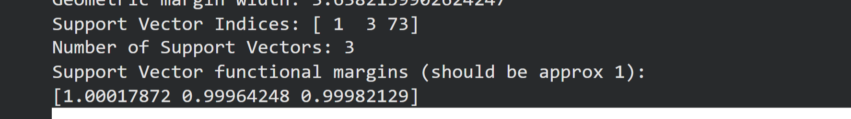

Task C2: Visualization (2 Marks)
Implementation Box
Highlight support vectors on the plot.
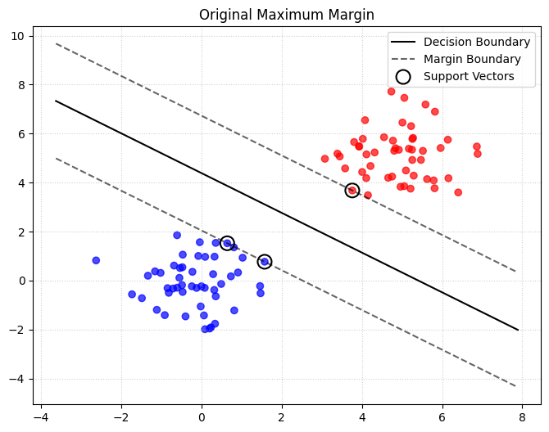

- Part D — Removing a Support Vector (2 Marks)
Remove one support vector. Retrain model.
Plot new boundary and compare.

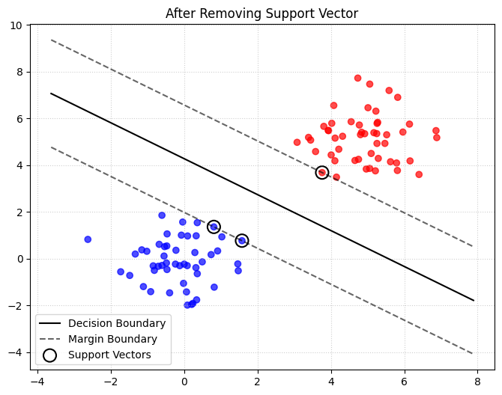
- Part E — Scaling Experiment (2 Marks)
Experiment Box

Multiply all features by 10. Retrain model.
Compute new margin. Explain change.
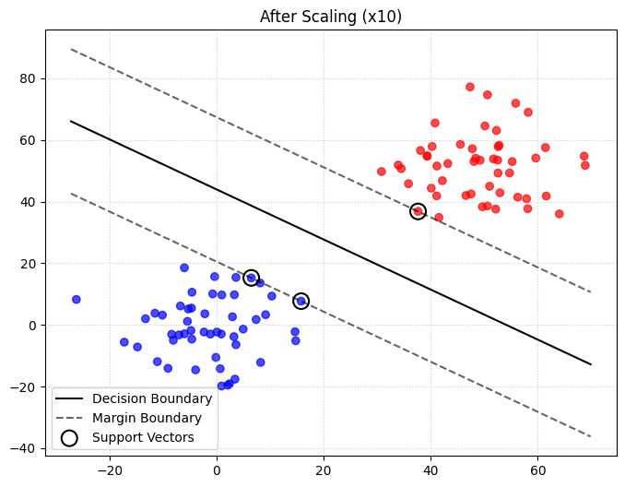
New Margin Width after scaling: 36.382163412842324
Scaling up your data shrinks the weights, which stretches the margin width, but the actual classification stays exactly the same.

- Reflection (2 Marks)
Reflection Box
- Why do only support vectors determine the solution?
The SVM optimization aims to maximize the empty area (margin) between classes. Because support vectors are the points lying exactly on the boundaries of this margin they act as the constraints that prevent the boundary from moving further. Any point further away already satisfies the safety requirement (>1) and does not push against the boundary.

- Why does scaling change margin but not classification?
Classification depends on the sign of w^T x + b, which remains unchanged if both the data and the weights are scaled proportionally. However, the geometric margin is 2/
||w||. When features are multiplied by 10, the weight vector w must decrease by a factor of 10 to keep the functional margin at 1, which in turn increases the geometric margin width.

